Users and groups

**How to create user:**

add user <optin><username>

eg.sudo adduser emp1



verifiy user is created

sudo su /etc/passwd

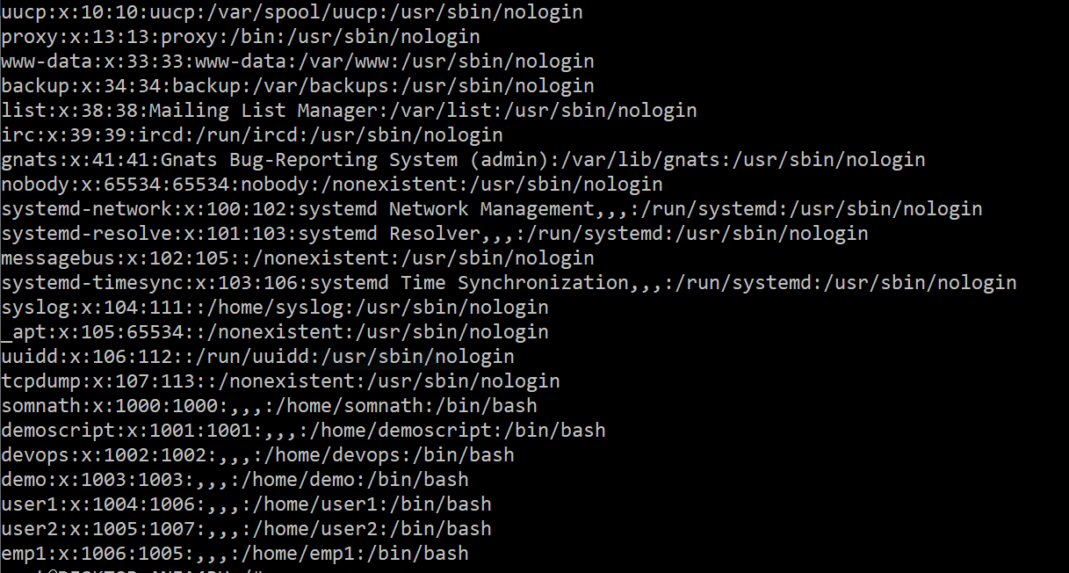

**How to create system user**

Sudo adduser –system username

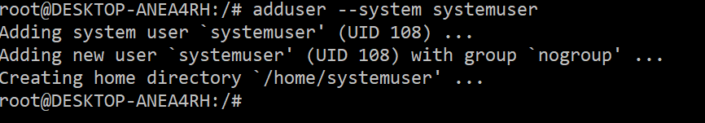

**How to create group:**

Sudo addgroup developer

Verify group is created



